1. [**Tracing FDA Design Considerations to 510(k) Submission Documents**](https://confluence.hl7.org/display/GP/Topic%3A+Tracing+the+FDA+Design+considerations+for+interoperable+systems+to+510%28k%29+submission+documents)

|  |  |  |
| --- | --- | --- |
| Sections No. [1] | 510(k) Sections1 | Interoperability Contents for Pre-market Submissions[2] |
| **1** | **Medical Device User Fee Cover Sheet (Form FDA 3601)** | N/A |
| **2** | **Center for Devices and Radiological Health (CDRH) Premarket Review Submission Cover Sheet (Form FDA 3514)** | N/A |
| **3** | **510(k) Cover Letter** | N/A |
| **4** | **Indications for Use Statement (Form FDA 3881)** | Depending on the purpose of the interface it might or not have an impact/be mentioned on the intended use of the subject device. |
| **5** | **510(k) Summary or 510(k) Statement** | [3]Although not explicitly mentioned in the Interoperability Guidance, 510(k) Summary must include a *“description of the device such as might be found in the labeling or promotional material for the device, including an explanation of how the device functions, the scientific concepts that form the basis for the device, and the significant physical and performance characteristics of the device, such as device design, material used, and physical properties”*; [807.92(a)(4)].  As such interoperability with other devices would also need to be described in the 510(k) summary. |
| **6** | **Truthful and Accuracy Statement** | N/A |
| **7** | **Class III Summary and Certification** | N/A |
| **8** | **Financial Certification or Disclosure Statement** | N/A |
| **9** | **Declarations of Conformity and Summary Reports** | FDA encourages the use of recognized standards for the development and design of interoperable medical devices. In such cases following should be included in the submission1:   * Declaration of conformity to the standard or summary report (as recommended in the relevant device-specific guidance); or * The basis of general use of the standard along with the underlying information or data that supports how the standard was used. |
| **10** | **Device Description** | In addition to (subject) device description, the information related to the interoperability of the device should include:   * Description of the externally facing electronic interface, * Purpose of each interface, * Anticipated users of the interface * Description of how each interface is meant to be used and/or the limitations of the use of the interfaces. * Description of the exchanged information (how data is exchanged and what impact it has on device and other impacted devices). Examples of some elements to be included: * *Explanation of the purpose of the interface and the role the device plays within an interoperable system.* * *Specify if the interface is meant to transmit, receive, or exchange information* * *Specify any standards used including relevant version numbers and dates* * *Describe the requirements for timeliness and the integrity of the information (e.g. sample rate, transmission rate)* * *Describe the communication format, rate, and transmission method* * *Discuss the limitations (what the user should not do), contraindications, precautions, and warnings* * *Describe the functional and performance requirements; and* * *List the Application Programming Interface (API) if the device is software that can be used by other software, medical device or system* |
| **11** | **Executive Summary/Predicate Comparison** | 1The Executive Summary of the 510(k) should include a:   * *Concise description of the device, including the indications for use and technology;* * *Device comparison table; and* * *Concise summary for any performance testing in the submission.*   Although concise, the section should provide an overall understanding of the device, which would also require the description of the interoperable functions of the device. |
| **12** | **Substantial Equivalence Discussion** | 1In the substantial equivalence discussion section, provides a detailed comparison between the subject device and the predicate. Substantial equivalence of the devices should be demonstrated, as applicable, in terms of:   * *indications for use;* * *technology; and* * *performance specifications, including any testing.*   Any new/changed interfaces when compared to the predicate, would need to be listed in the substantial equivalence table. |
| **13** | **Proposed Labeling** | Labeling submitted for FDA review should include information regarding the electronic interface on the devices, to ensure that the device can be used safely and effectively. The information should enable users to connect to the device in the specified manner, and should give instruction on how to use the connection to the device in the ways for which it was designed. Any limitations of the connection should also be included in labeling to avoid misuse of the device. Labeling should also indicate with which other specific devices or technologies the subject device is intended to operate with. If certain interfaces are only to be used by technicians for software updates or diagnostics, this information should be clearly indicated in the labeling.  Following information be included in the device labeling:   * *The purpose of the interface including any devices, device types, interface standard/specification, or software (including the version of the software) with which it is meant to connect;* * *The anticipated user(s);* * *Whether the connection is meant to control the operations of another device;* * *Specifications for each interface (e.g., physiological waveforms, probe type, accuracy, frequency of response, update rate, data rate, bandwidth), as well as the necessary performance and functional requirements from the device related to the sending or receiving of data/control;* * *List of the data attributes being exchanged;* * *Summary of the testing performed on the interfaces to verify interoperability claims and any activities suggested for the user to verify safe operation. In the case where testing was performed to an interface specification and verified with a representative device, the manufacturer should specify the representative device used;* * *Relevant standards used and certifications received;* * *Any method used for time synchronization;* * *A description of any fault tolerance behavior, boundary condition testing, or fail safe for critical functions (e.g., delivering energy) that will allow the user to understand how to use the interface correctly;* * *Any known limitations (what the user should not do), contraindications, precautions and warnings;* * *Recommended connections;* * *Recommended settings, or configurations for the electronic interface; and* * *Instructions for specific users such as IT personnel on how to connect or install and disconnect or uninstall the device.* |
| **14** | **Sterilization and Shelf Life** | N/A |
| **15** | **Biocompatibility** | N/A |
| **16** | **Software[4]**  *[Level of Concern, Software Description, Device Hazard Analysis, Software Requirements Specification (SRS), Architecture Design Chart, Software Design Specification (SDS), Traceability Analysis, Software Development Environment Description, Verification and Validation Documentation, Revision Level History, Unresolved Anomalies (Bugs or Defects)]* | The Device Hazard Analysis submitted for the subject device should capture the risks associated with interoperability as well as risks associated with a system, which contains more than one connected medical device.  The Device Hazard analysis should include analysis of the interface or interfaces on the (subject) devices, their intended connections, and any effects that the connection may have on the device performance. The submitted risk analysis should include hazards that were considered, possible hazardous situations, the risks that may result from each, and how the hazards and risks were addressed.  Examples of some elements to be included:   * *The risk control measures for reducing unacceptable risks to acceptable levels;* * *Fault tolerant behavior, boundary conditions, and fail safe behavior such as how the device handles delays, corrupted data, data provided in the wrong format, unsynchronized or time mismatched data, and any other issues with the reception and transmission of data;* * *Any risks potentially arising from security vulnerabilities that may be involved with the presence of an electronic interface; and* * *Risks arising from normal use as well as reasonably foreseeable misuse. For example, a manufacturer may want to include in the labeling an explicit warning against foreseeable uses that could result in harm.* |
| **17** | **Electromagnetic Compatibility and Electrical Safety** | During the design process following should be considered:   * *Whether implementation and use of the interface degrades the basic safety or risk controls of the device;* * *Whether implementation and use of the interface/interfaces degrades the essential performance of the device as defined in IEC 60601-1;* * *Whether appropriate security features are included in the design; and* * *Whether the device has the ability to handle data that is corrupted or outside the appropriate parameters.*   Interoperable system should maintain basic safety and essential performance during normal and fault conditions. |
| **18** | **Performance Testing – Bench** | In addition to the (subject) device performance testing, the results of verification and validation testing for the electronic interfaces should also be included in the submission.  Devices that only operate with specific devices, can demonstrate testing with those specific devices. Devices connecting with a class of devices or that can be used by any device or computer system can rely on testing with a representative device. Performance testing for the electronic interfaces should include:   * *Verification that the device interface meets its design specifications;* * *Validation that the device interface performs as intended;* * *Determination and verification of the information that should be provided to a user to connect to the interface and to allow the user to ensure that the connection has been made correctly; and* * *Verification that the device will perform safely and within specification when used under normal conditions and abnormal conditions that are reasonably likely to occur (e.g. receives data outside of specification, connected to an unintended device or system, does not lock up the system when the interface is exercised).*   Complete Test Reports vs. Summary of Test Reports:  According to FDA’s interoperability guidance *“for those elements of the interface that use a standard, demonstrating conformance to that standard may be sufficient. If the purpose of the interface along with the intended scenarios for use of the interface do not add significant risk to the operation of the medical device, then test summaries may be sufficient”.* |
| **19** | **Performance Testing – Animal** | N/A |
| **20** | **Performance Testing – Clinical** | N/A |

1. **Interoperability Design Considerations from Guidance**

*[excerpts from the FDA Guidance “Design Considerations and Premarket Submission Recommendations for Interoperable Medical Devices”]*

**Purpose of the Electronic Interface:**

Device manufacturers should consider the purpose for each of the electronic interfaces. This should include the types of data exchanges taking place (e.g., sending, receiving, issue command and control).

* types of devices that it is meant to connect to;
* type of data exchange taking place (e.g., sending, receiving, issue command and control);
* the use of standards (e.g., data format, transmission, interface standards, standard terminologies);
* the need for time synchronization;
* method of data transmission;
* the necessary timeliness and the reliability of information (e.g., sample rate, transmission rate);
* what the user should or should not do with the electronic interface including contraindications, warnings and precautions on the use of the exchanged information;
* clinical context for the use of the information exchanged in the interface, such as an infusion pump used to deliver anesthesia to a sedated patient in the intensive care unit;
* interoperability scenarios for the use of the interface, i.e., how the manufacturer anticipates the interface being used. For example an interface on a pulse oximeter is used to send data to a computer system in an eight hour study on neonates to assess sleep. The computer system is also gathering information from ECG. Therefore the information from the pulse oximeter and ECG need to have their times synchronized and data collected at a specific rate. Knowing the scenario would demonstrate the need for specific features;
* the functional and performance requirements of the device as a result of the exchanged information;
* expected flow of information or exchange of information through an application programming interface (API) which may include considerations of acceptable and unacceptable commands on the interface and impact of such interface on the device safety and effectiveness; and
* the transmission of metadata (e.g., unique device identifier (UDI), software version, configurations, settings).

**Anticipated Users:**

Manufacturers should determine the anticipated user(s) for each of the electronic interfaces. Examples of users include: clinical user, biomedical engineers, home healthcare user, IT (information technology) professional, system integrator, system designers, patients, researchers, and medical device designers.

* users, operators, and clinicians need to know the clinical uses and potential risks relevant to the use environment and the clinical task at hand;
* equipment maintenance personnel and hospital clinical engineers need to know what actions to take to verify correct configuration and operation. They need to assure that the system is performing as specified;
* IT professionals need to understand the performance needs and security requirements of the devices connected to the networks they maintain and operate;
* system integrators, system designers, and medical device designers are responsible for the safe and effective operation of their systems or devices and need to know the capabilities of the components they use so that they can perform adequate risk management and validation; and
* patients may need specific instructions on how to use their device in a home environment.

**Risk Management:**

Manufacturers should consider ways to mitigate risks identified in the risk analysis. This includes risks that arise from others connecting to the electronic interface.

* whether implementation and use of the interface degrades the basic safety or risk controls of the device;
* whether implementation and use of the interface/interfaces degrades the essential performance of the device as defined in IEC 60601-1;
* whether appropriate security features are included in the design; and
* whether the device has the ability to handle data that is corrupted or outside the appropriate parameters.

Considerations on basic safety and essential performance during normal and fault conditions.

* failures or malfunctions caused by direct or indirect connection of intended devices;
* failures or malfunctions caused by invalid commands;
* failures or malfunctions caused by receiving and processing erroneous data or commands; and
* failures or malfunctions caused by not adhering to the non-functional requirements of the communication specification. By non-functional requirements, FDA refers to the examples listed in ASTM 2761-09(2013)(e.g., bandwidth, latency, time synchronization).

**Verification and Validation:**

Manufacturers should establish, maintain, and implement appropriate verification and validation to ensure that their devices with electronic interfaces work correctly prior to delivery, during the integration process, continue to work while in use, and through maintenance and release of software updates.

* verify and validate that when data is corrupted it can be detected and appropriately managed;
* perform testing to assure that the device continues to operate safely when data is received in a manner outside of the bounds of the parameters specified. Determine how or whether this can be detected and what impact this will have on the rest of the system;
* implement a fault-tolerant design and verify its performance;
* establish and specify fail safe states for critical functions (e.g., delivering energy, real-time monitoring);
* if conforming to consensus standards, verify and validate that the design meets the intent and scope identified in the standards;
* verify only authorized users (individuals, devices and systems) are allowed to exchange information with the interoperable medical device;
* validate the user(s) interface. Determine that the user(s) are capable of correctly using the interface(s);
* assure that reasonably foreseeable interactions do not cause incorrect operation of other networked systems; and
* conduct testing that simulates real-world use of the device.

1. **Interoperability Structure in eSTAR**

*[For non-In Vitro Diagnostic Medical Devices Version 1.1 (2021-12-17)]*

*Screenshot from eSTAR*

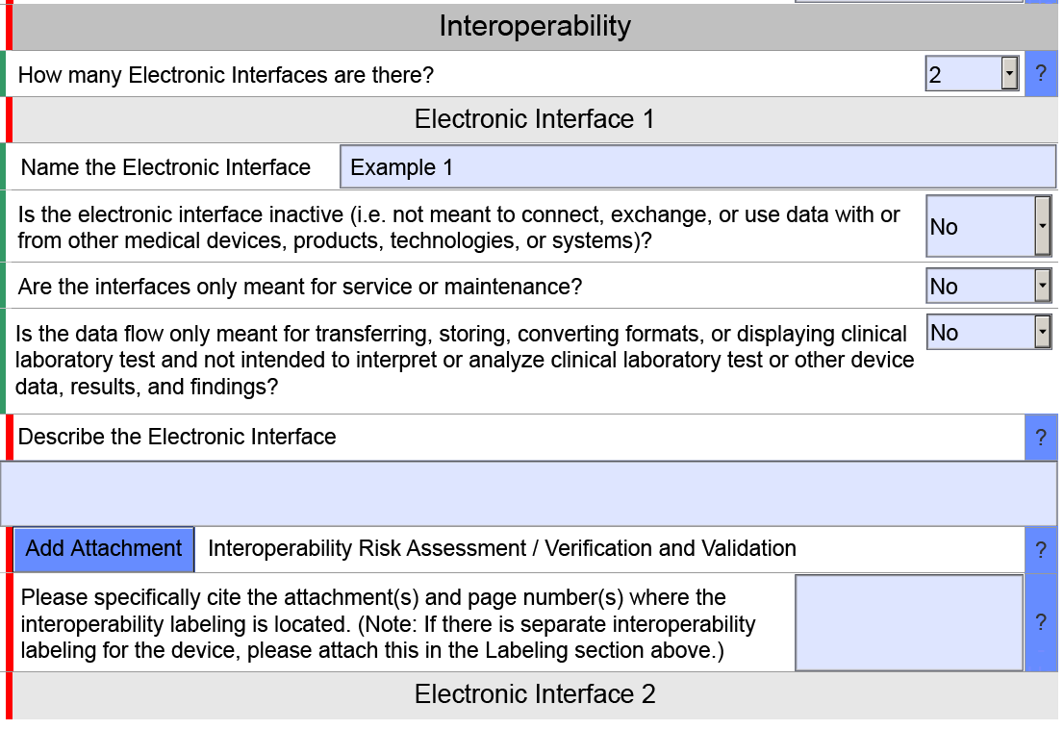

1. Per FDA Guidance “Format for Traditional and Abbreviated 510(k)s”, issued on September 13, 2019.
2. Per FDA Guidance “Design Considerations and Premarket Submission Recommendations for Interoperable Medical Devices”, issued on September 6, 2017.
3. Per 21 CFR 807.92, in paragraph (a) (4)
4. Encompassing content per FDA Guidance „Guidance for the Content of Premarket Submissions for Software Contained in Medical Devices“ issued May 11, 2005